DATABASES FOR BUSINESS ANALYTICS: Assignment 3

Kristen Sosulski 9/17/2024

Please create a Google Doc for this assignment in your .nyu.edu account. Be sure to include your name and clearly label the answers to each question. Then, upload your document from your GoogleDrive to Content > Lesson 3 > Assignment 3 in Brightspace.

**Assignment 3 - The logical and physical data models**

* Review the restaurant data from assignments 1 and 2.
* Next, revise your data dictionary and ER UML diagram to ensure you have a three-table design that includes reviewer, rating, and restaurant entities. You will use the three-table design to create the logical and physical data models for your restaurants database. 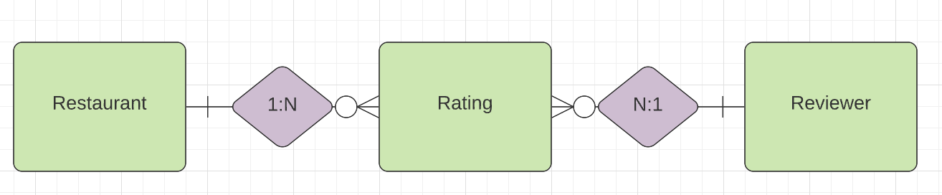

**Part 1**

Create a logical model of the restaurants database. For this assignment, only create the Restaurant table and the Reviewer table. We will create the Rating table in class.

Creating the two tables requires you to use SQL to build your database and two tables. Provide the SQL code for your database and tables. Be sure to document your code to describe the different aspects of the SQL code clearly.

**Part 2**

Create the physical model of the restaurants database. This requires implementing the code from Part 1. To demonstrate that you successfully implemented the model, take a screenshot of your MySQL WorkBench that shows the Action Output window.

图形用户界面

**Part 3**

Populate and query your database. Specifically, complete the following:

1. a) Show the data structure for each table using DESCRIBE. Then, take screenshots of the output of the Results Grid.

1. b)  Insert the data (based on the original data in assignment 2) into your database tables. Include the SQL code used to populate those tables. Take screenshots of the Action Output to demonstrate your successful population of the tables.

1. c)  Come up with two simple queries demonstrating your ability to interact with your database tables. Include the question each query answers, the SQL code itself, and screenshots of the Results Grid.

